Java Tutorial

Que : What is java ?

Java is programming language and its platform which is use to create the application
Application like
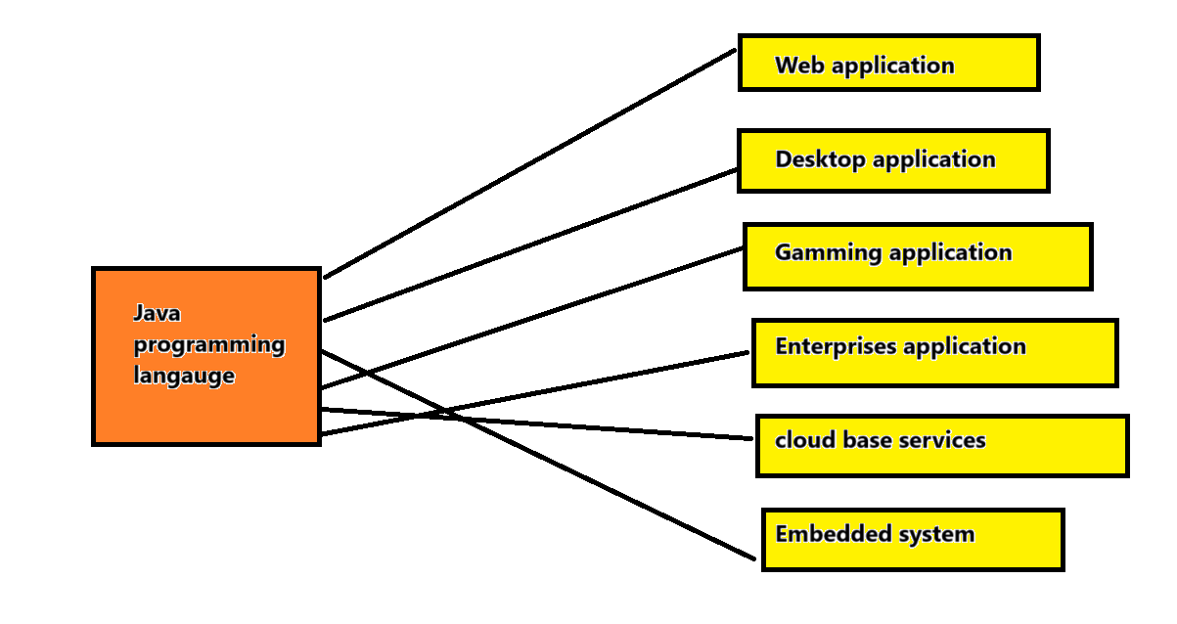
Que: Why people called it as platform ??
java is often refer as platform for several reason due to its philosophy design and one of the most presence of Java virtual machine (JVM )
Also building application is kind of platform to create or made something using language
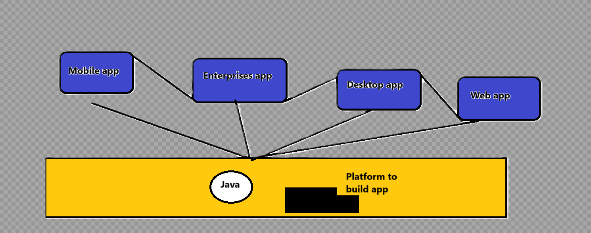

Que :What is full form JAVA
Its come into the picture is Just Another virtual Accelerator
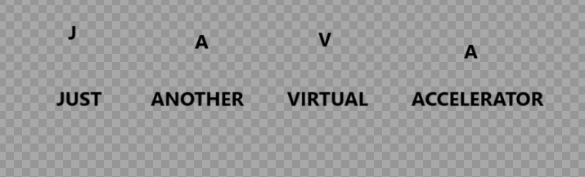
Que: Explain using to specify it is a platform?
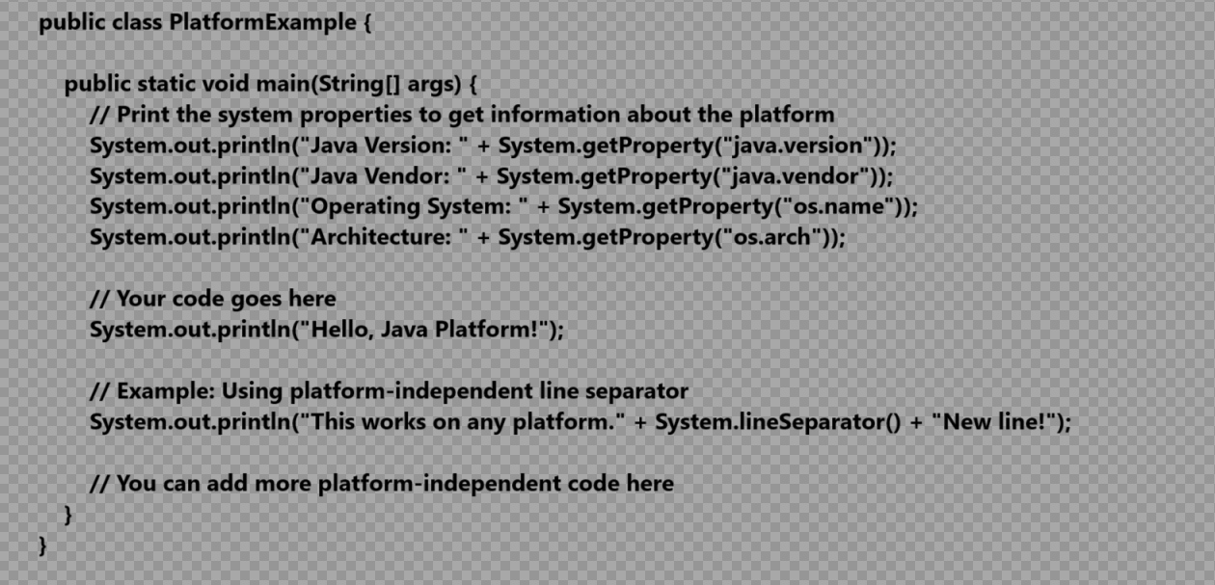

When we run this program on different platform it able to get the specific characteristics
Each platform
Que:-Who was developed the Java??
Java was developed by Sun Microsystems (which is now the subsidiary of Oracle) in the year 1995. James Gosling is known as the father of Java. Before Java, its name was Oak. Since Oak was already a registered company, so James Gosling and his team changed the name from Oak to Java
Initially the team who developed java called green team on that the name of the java is Green talk and the extension of java is “.gt” later on when oak comes to the picture suffer from the several reason for the name it has changed to Oak (national tree technology also use oak as tree also oak technology complaints )

In 2020 jdk 15 is stable version comes and later on it become more popular language

Que :What is platform ??

Any hardware or software environment where program is run called “Platform”
Since java has run time environment (JRE) and api to run the program so it is called platform

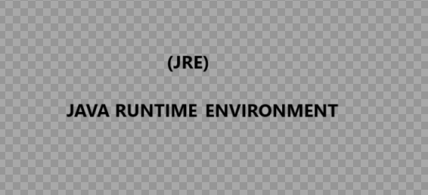

Que :First version of java ??
in jan 23 1996 ,jdk 1.0 is first version used to stable version called java 1
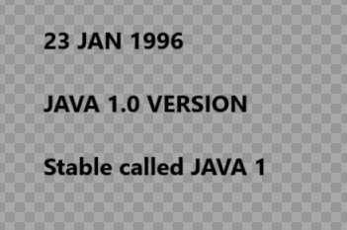

Que : Why java comes in to picture at the 1990 scenes ?

Software development teams faces several challenges during building the software
Like
1.Plateform independence
2.Security
3.Object oriented language
4.Automatic memory management
5.Rich standard libraries
6.Community Driven Development

Que: Why sun microsystem sell out java to oracle ?
In 2006 oracle acquire the java from sun microsystem its because of some reason that may cause
1.Financial issue
2.java integration with oracle
3.strategic fir with oracle
And many other ..
Que: What is edition in java??
The term edition is related with new version or release of java development kit in market
It is nothing but the stable release or “Platform”

Que: What are different types of edition in java?
There are mainly four types of edition or platform of java

1.Java standard edition
2.Java Enterprises Edition
3.Java Micro Edition
4.Java Fx

Que : Why java need this edition in market ?
In market the feature and specific api are in use cases to use those concept java has specific use of “api” or feature that can admire the use case

Que: What is java standard edition ?
This is the core Java platform that provides the basic libraries and APIs for developing desktop, web, and server applications. It includes the Java Development Kit (JDK) and is commonly used for general-purpose programming.
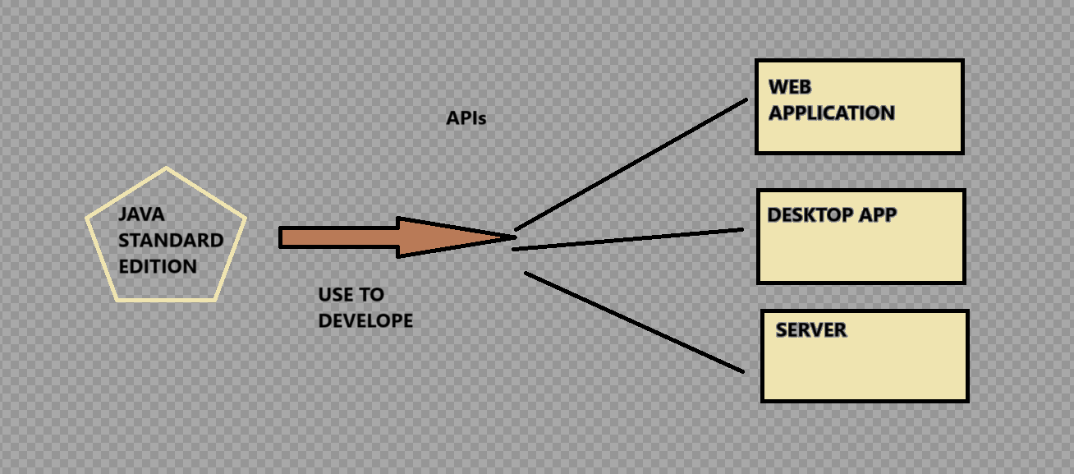

The apis include in java standard edition are
Java.lang
Java.util
Java.sql
Java.math etc
It include more topics like OOPS ,string ,Regex ,exception ,inner classes ,multithreading ,io stream ,AWT ,Collection
Java SE continues to evolve, with ongoing efforts to improve performance, security, and developer productivity.

Que: what is java enterprises edition ?
It set of specification and apis that extended the java standard edition
This platform use to build the web application and mainly enterprises application
It include
1.servlet
2.JSP
3.Web services
4.EJP
5.JPI
Etc

Note: Java enterprises edition Know as Jakarta EE
Which was developed in sun microsystem but later on it transitioned to eclips foundation
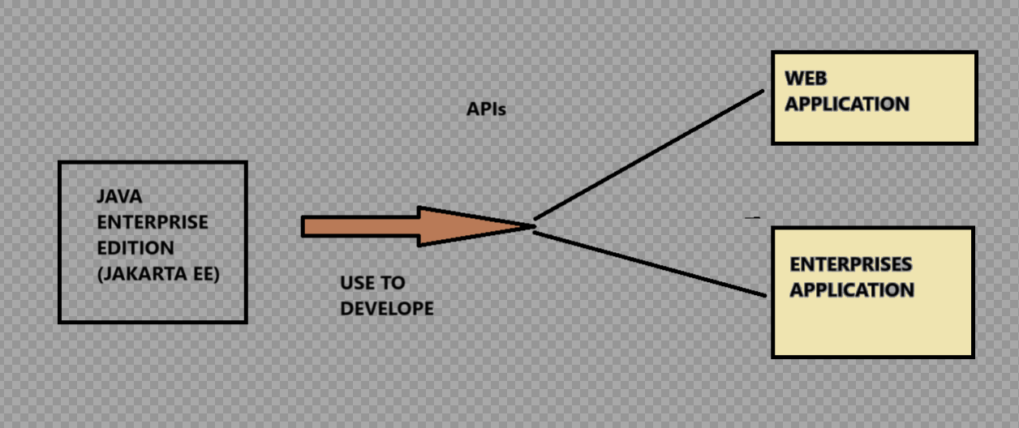

Que: what is java micro edition ?
It is platform that use to developed the constraint devices such as mobiles phones
, embedded system which has limited memory, processing power and storage
They use to purpose for java to small
Edition for portable devices allowing developers to write application
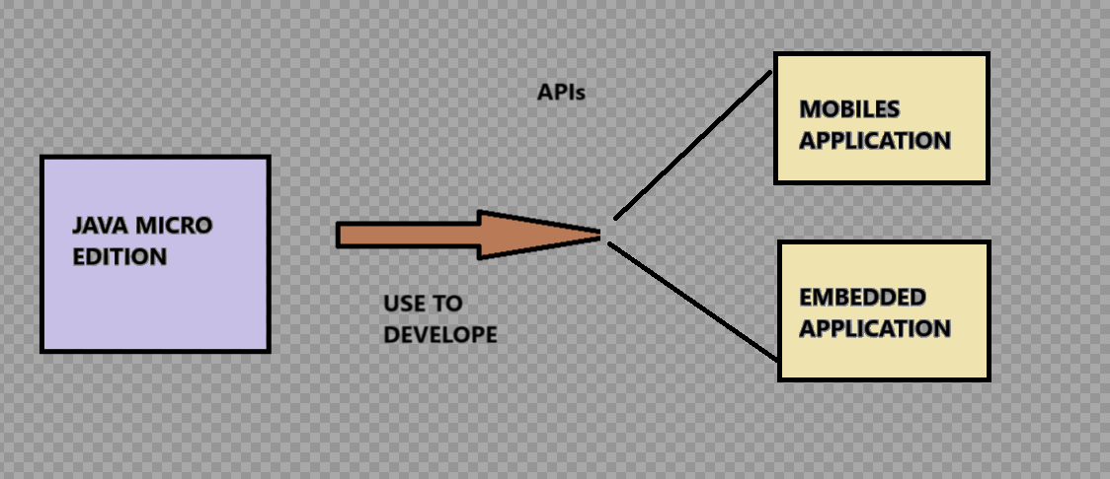

Que: what is java Fx?
JavaFX stands for special effects in the Java language. Internet applications are made richer with different plugins with the help of JavaFX.
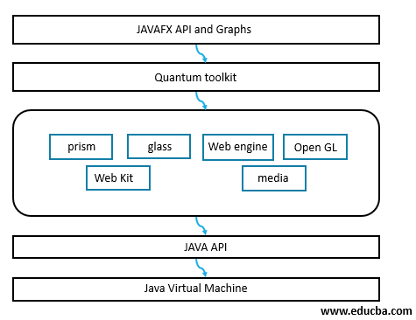
It is used to develop rich internet applications. It uses a lightweight user interface API.

Que : Features of java? What are the different feature used in java ?
One of the primary objective of java programming language is
1.java is portable (Bytecode and virtual machine relation)
2.java is simple (Clear syntax,automatic management , standard libraries
3.java is secure language (Security manager ,classloader ,Exception handling ,community focus)

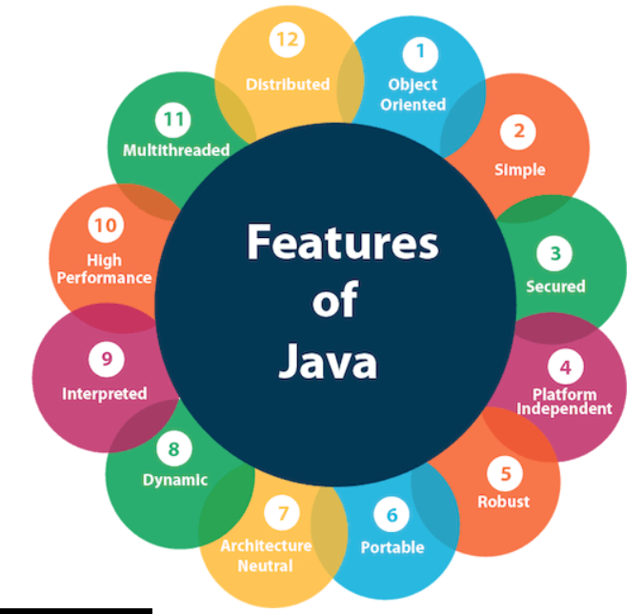

JAVA IS SIMPLE LANGAUGE
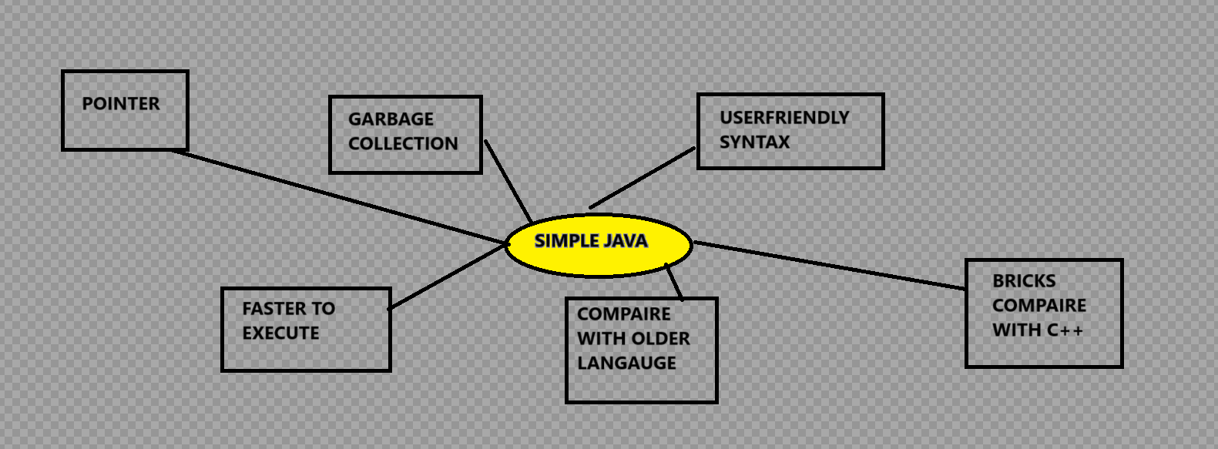
Java is very easy to learn, and its syntax is simple, clean and easy to understand. According to Sun Microsystem, Java language is a simple programming language because:
- Java syntax is based on C++ (so easier for programmers to learn it after C++).
- Java has removed many complicated and rarely-used features, for example, explicit pointers, operator overloading, etc.
- There is no need to remove unreferenced objects because there is an Automatic Garbage Collection in Java

JAVA IS OBJECT ORIENTED
Java is object oriented programming language which is one the mechanism where all over software is build using the object it means is based on object
2.object is encapsulate the data and behaviour of application when its interact with each other using one of the interface
Object oriented programming is methodology which having some rules
Like
1.Object
2.Class
3.Inheritence
4.Encapsulation
5.Abstarction
6.PolyMorphism
Platform Independent
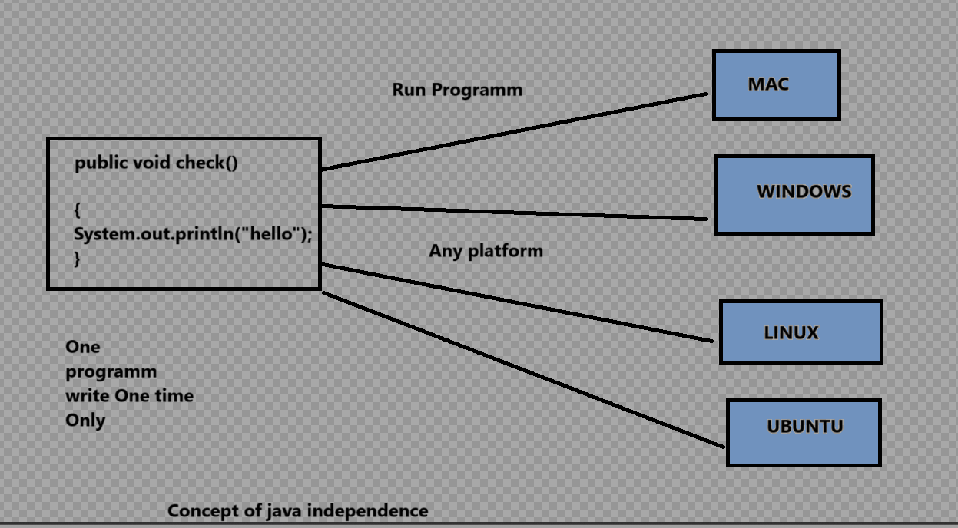
1.java if platform independence just because of its design ie “WRITE ONCE RUN ANYWHERE” (WORA) this feature is achieved through java virtual machine
2.The process of jvm is its compile the code into an intermediate level and then this is called as bytecode that bytecode you can run anywhere or in any platform
**Note :-JVM is platform specific because jvn support different software platform but you can run your code by converting it into bytecode
**Some key factor are contribute to make java independence
1.JVM
2.BYTECODE
3.WORA
4.JAVA STANDARD EDITION
Que: What are the types of platform ?
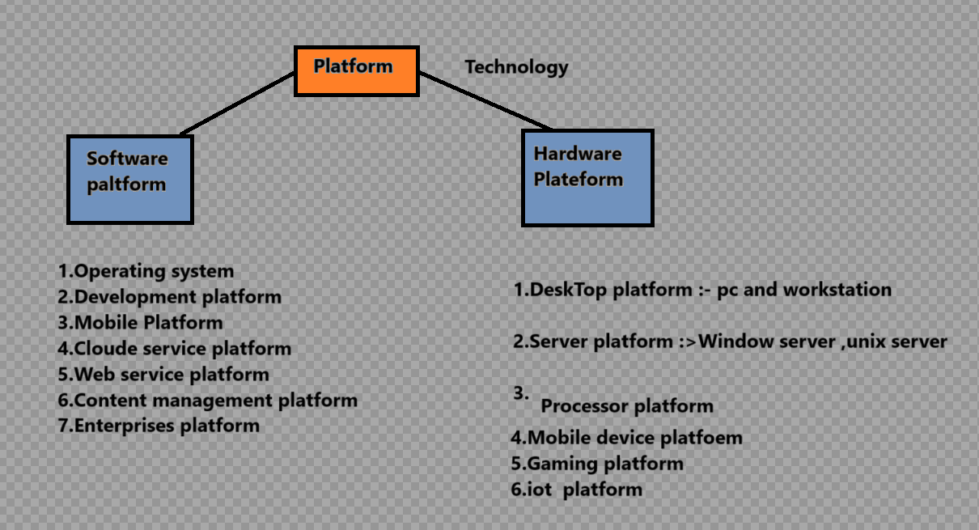

Que: Why jvm is software specified?
Jvm is provide the run time environment for the specific java code to bytecode
2.It act as intermediate layer between hardware compile machine and java source code
3.JVm is dynamical things to load class and library as needed during the execution of programme
4.JVM enable cross platform compatibility, optimization, portability, secure execution for the java programme.
Java is secure
1.Byte Code verification (By using JVM)
Java programs is compiled into bytecode, which is then executed by using by java
Virtual machine so before its execution JVM ensure some malicious code or verify the certain security constraints

Like It checks proper stack manipulation ( to manage the memory for method invocation ) , valid access of methods and fields and more mistakes etc.

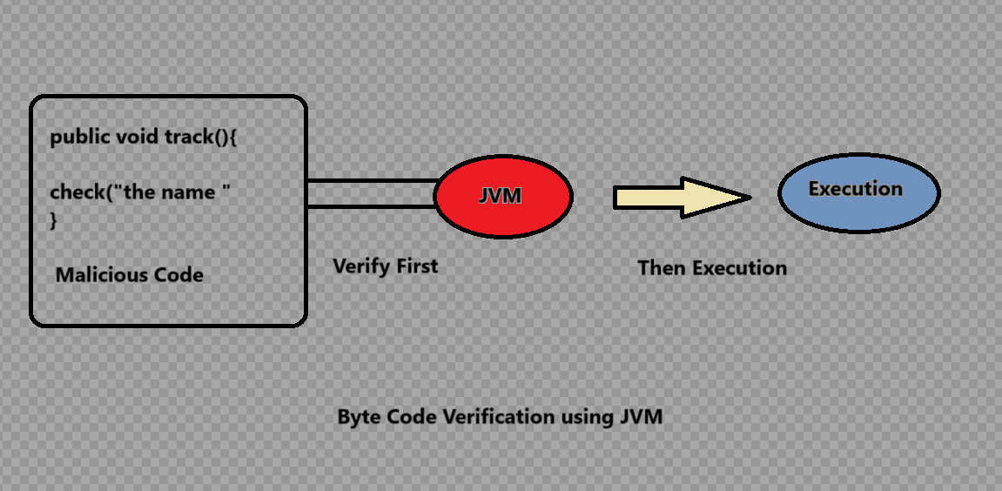

2. Memory management
Java used to automatic handle the memory management using garbage collection
That used to prevent the buffer overflow ,some of the error during execution which leads to create the vulnerabilities
There are two kinds of memory mostly handle in java project
1.Heap memory : that control the objects
2.Stack memory : that control the Local variables
Garbage collector is most factor used to control the memory management
Which store the object that are no longer reachable and it free up the space occupied by these object
(No garbage collector no memory impact on performance)
Example use in selenium is During garbage collector we can call it explicitly
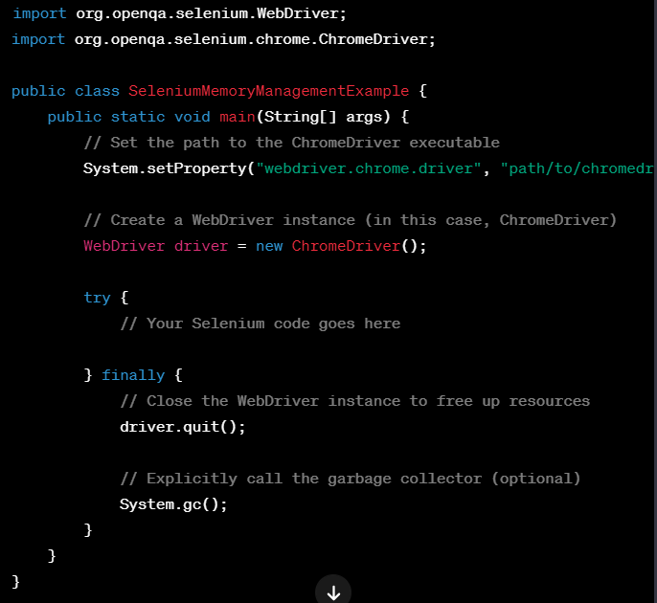

Here we call explicitly but we don’t need to call JVM will call automatically if no longer object is reachable

3.Classloader :
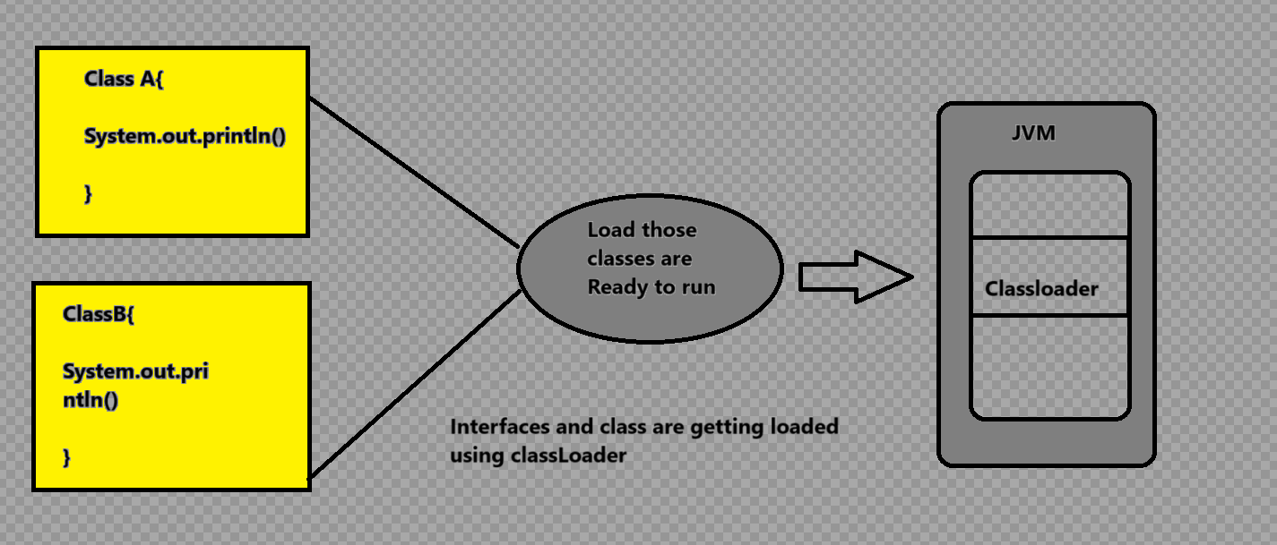
1.Class loader is subsystem of JVM which is used to load the classes and interfaces
Some of the class loaders usein java is
1.BoothStrap
2.Extension Class loader
3.System Class loader
4.Plugin Class loader
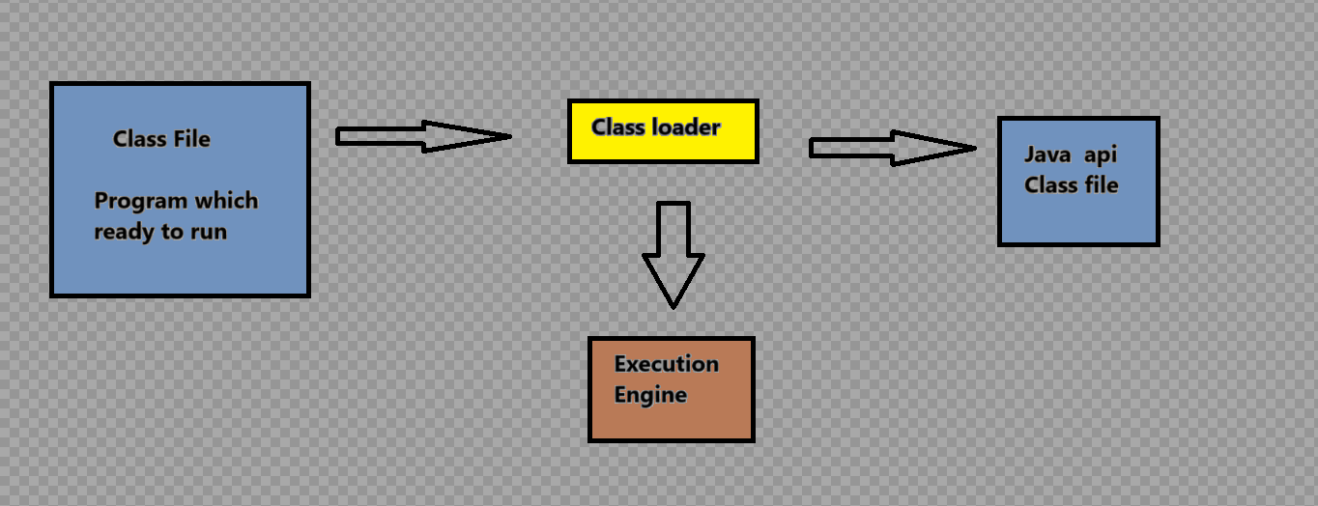
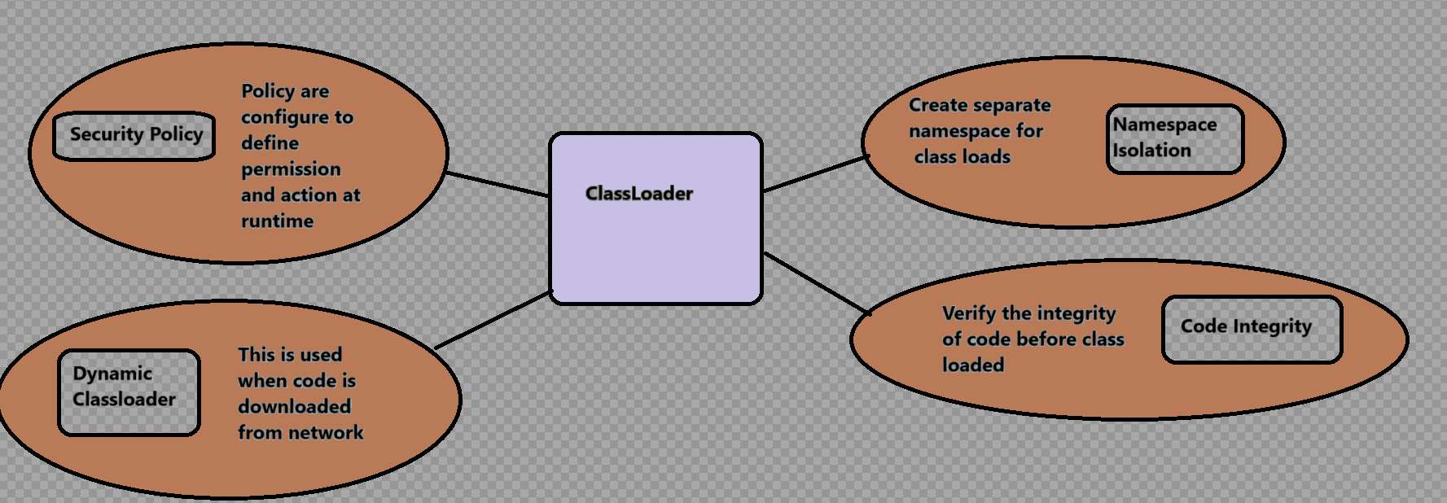

Above factors are combined to responsible for making java is secure

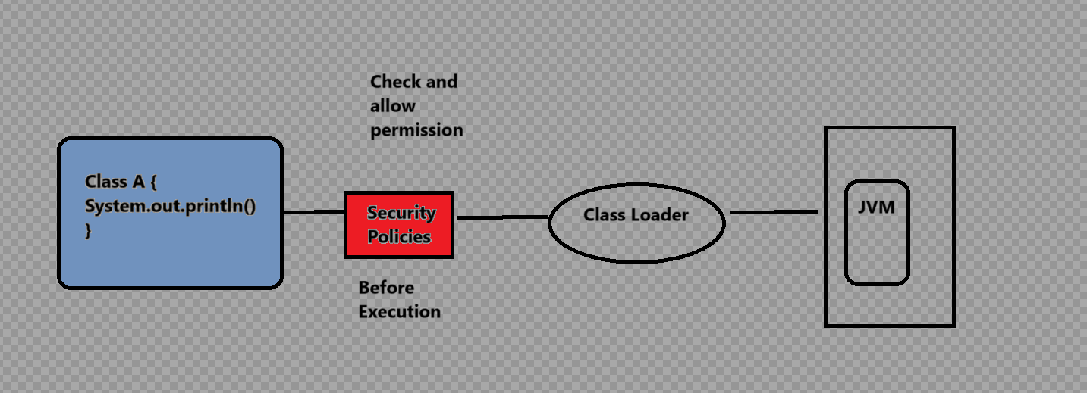

Java is Robust (Strong)

Robustness is meaning of handling the error and manage the incorrect input data
During the execution
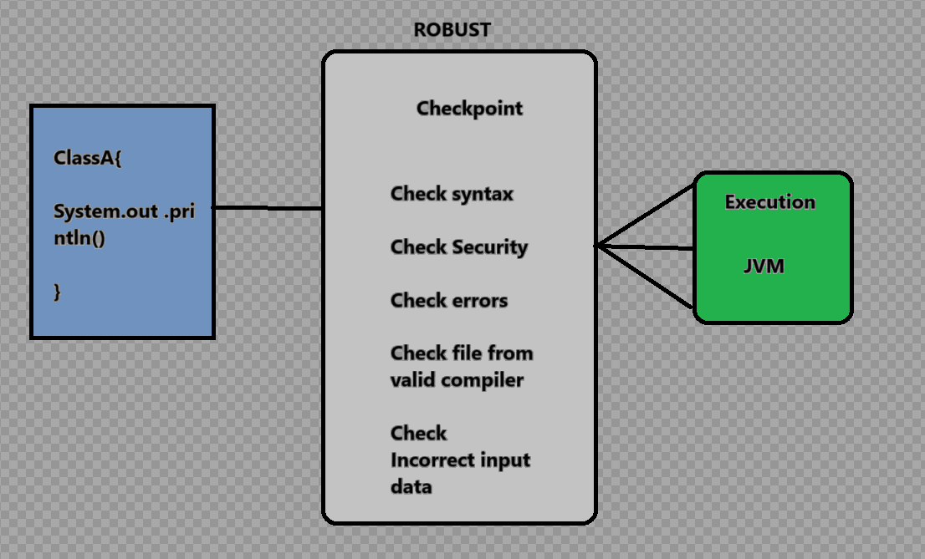

Java is robust in structure
There is absence of Pointer which avoids the security problems
Automatic garbage collection
There are exception handling and the type checking mechanism in java

Architecture Neutral

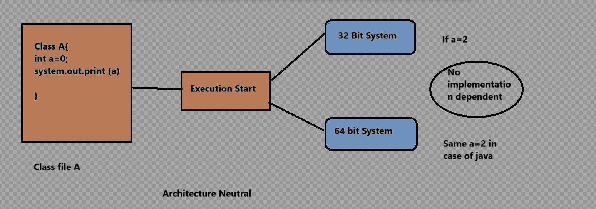
Java is architecture neutral because there are no implementation dependent features, for example, the size of primitive types is fixed.
In C programming, int data type occupies 2 bytes of memory for 32-bit architecture and 4 bytes of memory for 64-bit architecture. However, it occupies 4 bytes of memory for both 32 and 64-bit architectures in Java.

Java is Portable :
Portable meaning 1. Transportable 2. Movable
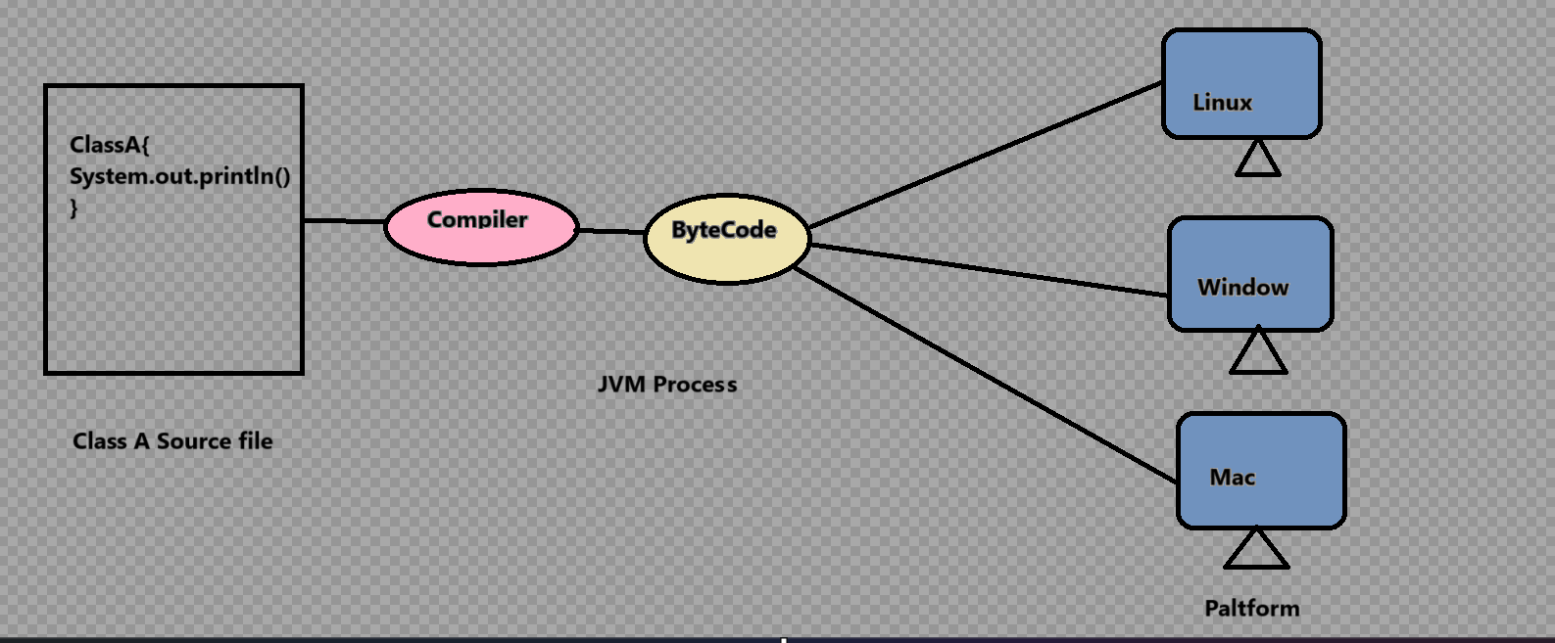

Java is portable because it facilitates to carry Byte code and run it on any platform that can be easily movable it does not require any implementation.
It means we can use the java source code from one computer and run it on any other computer

Java Is High Performance
Java is interpreted language so which leads to make java become High performance
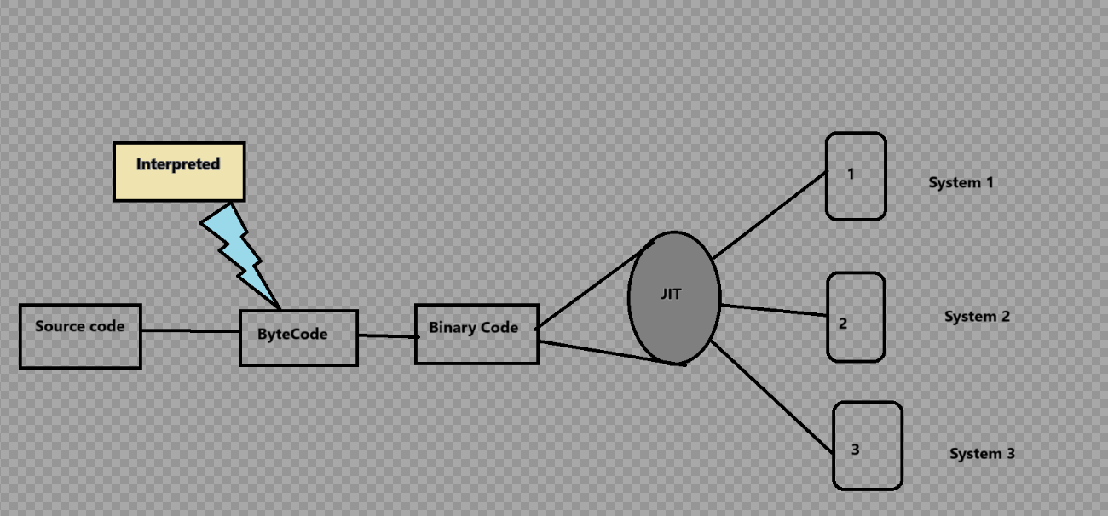

Some Key factory are important which leads to java is on High Performance
1.JIT
2.Garbage collector
3.Bytecode verification
4.Class loader
5.Native interface support

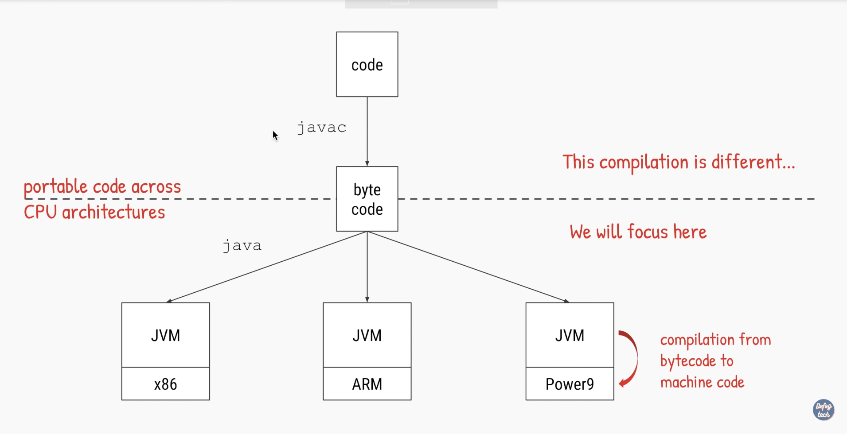
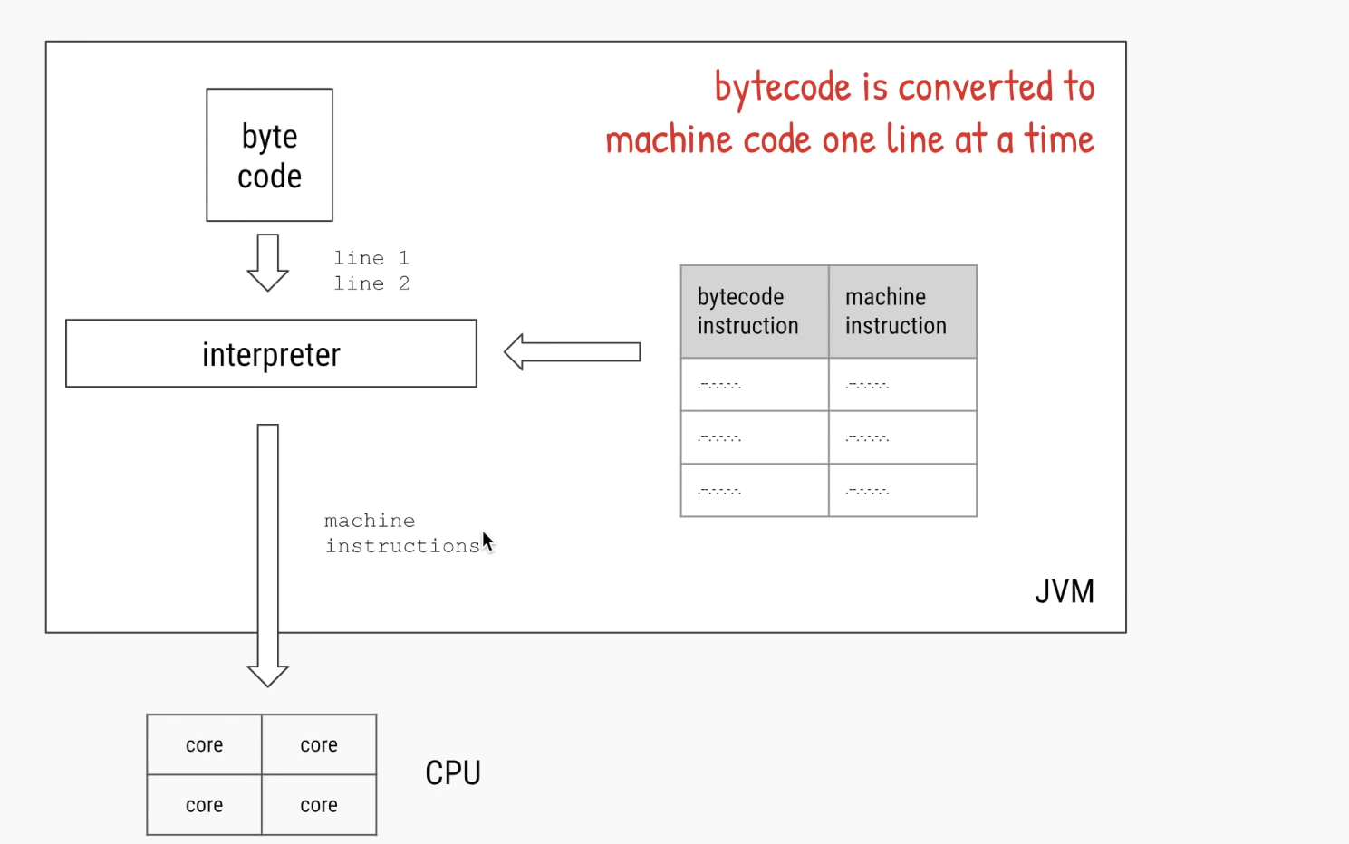

Java is Distributed

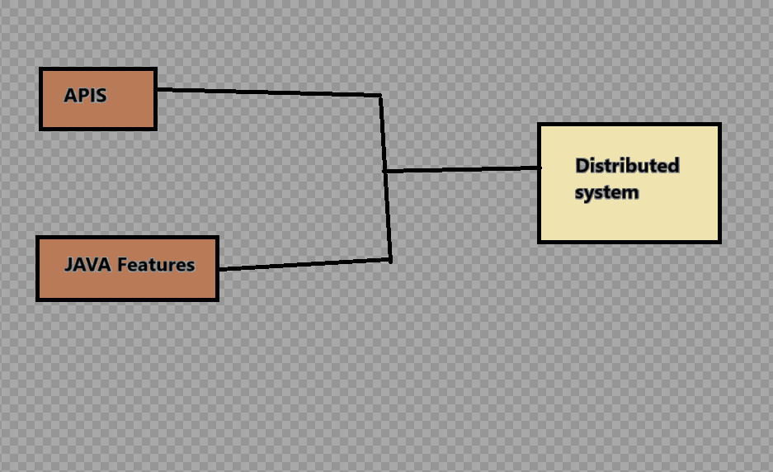
1.Some of the features and apis which facilitates to provide the development of distributed system or application

Distributed system /Application
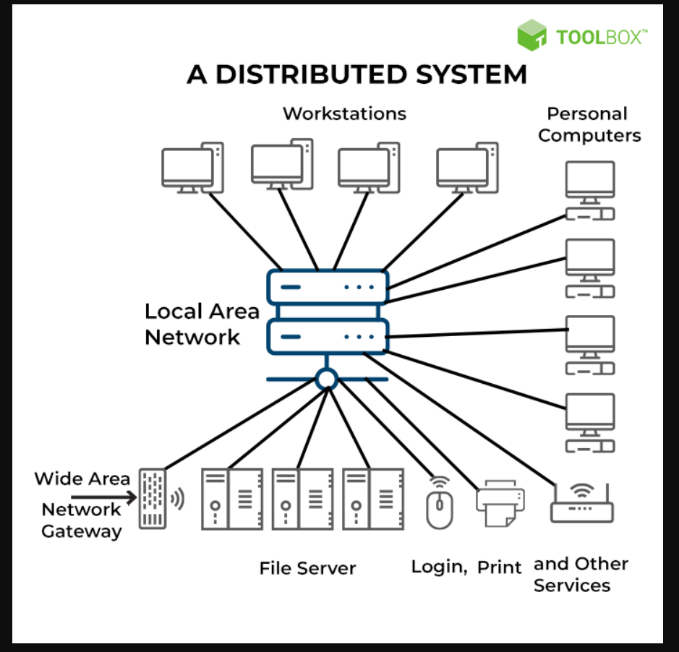
Some key factor use to involve in distributed system

1.REMOTE METHOD MECHANISM (RMI)
The RMI (Remote Method Invocation) is an API that provides a mechanism to create distributed application in java. The RMI allows an object to invoke methods on an object running in another JVM.
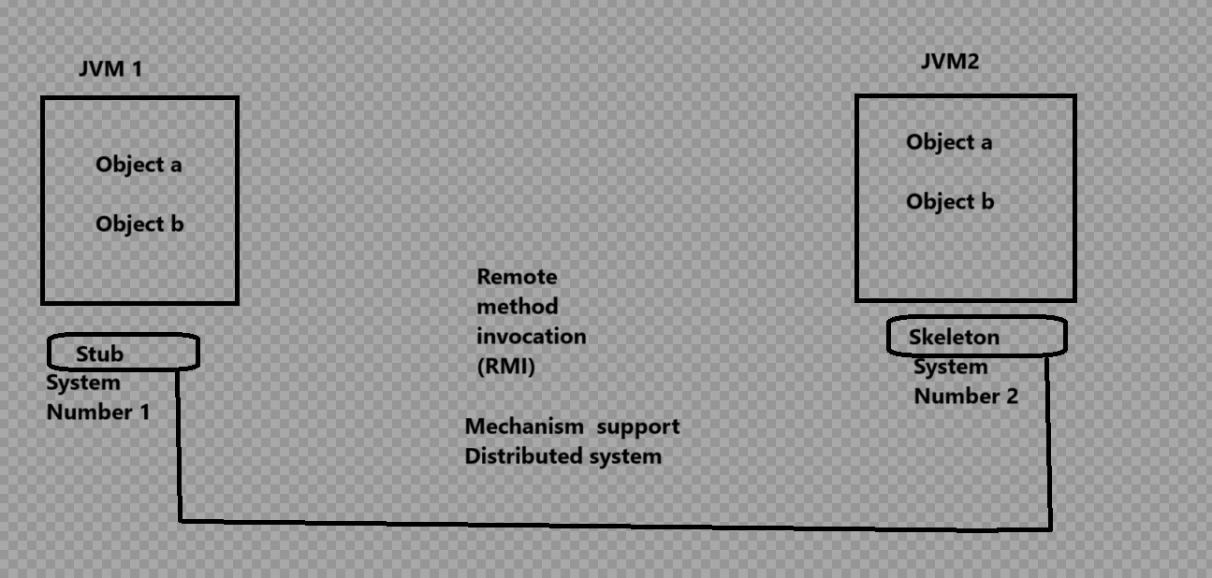

2.JAVA NETWORKING API
Java includes a set of networking APIs that allow developers to create networked applications. These APIs provide classes for working with sockets, URLs, and other network-related functionalities,
3.WEB SERVICES
JAX-RX and JAX-WS some other webservices also support to build the distributed system

Java is multithreaded
1.Multithreading is one of the powerful feature of java which used to improve the performance of the application
2.In multithreading technique we write the program once and provide the thread ,it can be perform the many task without occupy memory for each program there is common memory area
3.Thre program execution done concurrently.

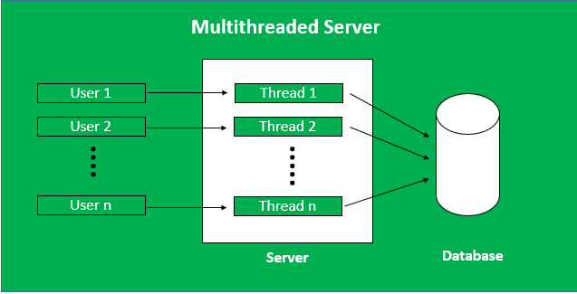
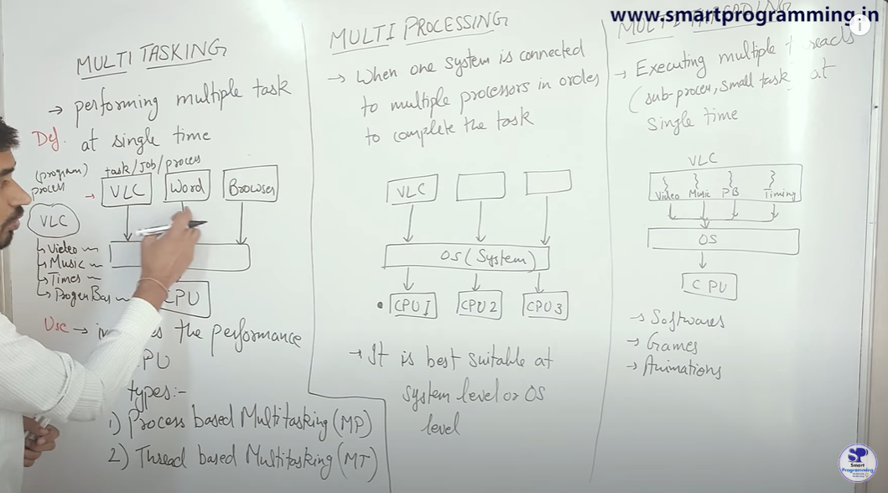

Note :Java provide predefine apis which is used to achieve the multithreading mechanism
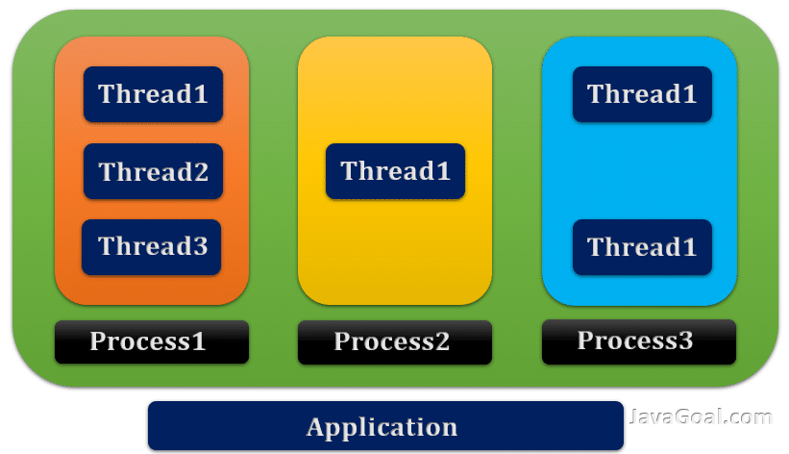

In java multithreading we can achieved by using thread and Runnable interface.

Java is Dynamic
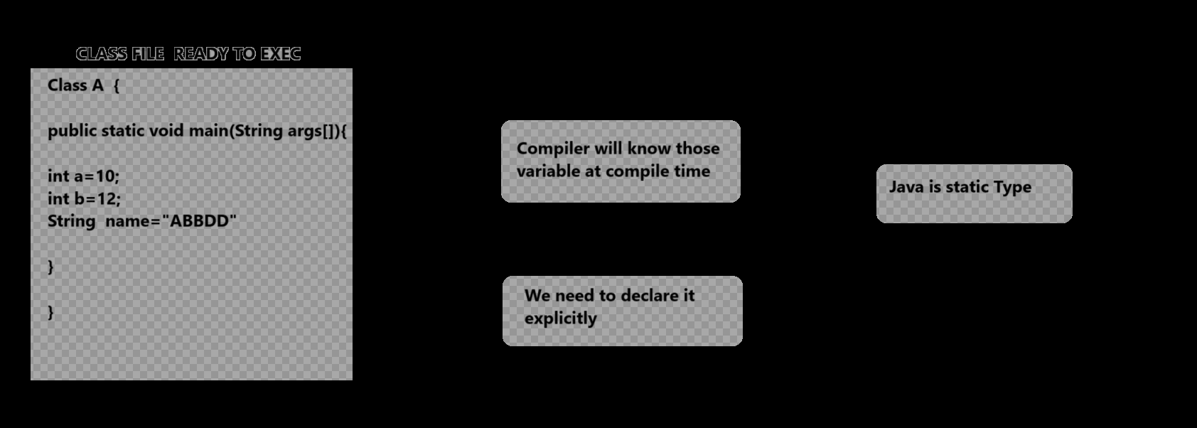

Some Dynamically type Programming language are as
Python ,Java scripts etc.
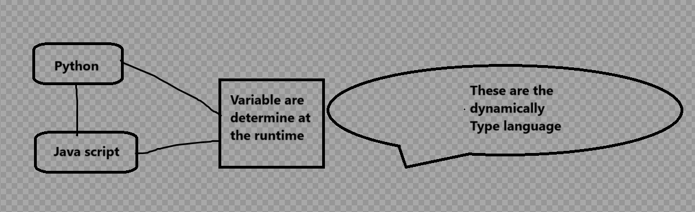

Some Key factor which makes java dynamically programming language
Dynamic Loading
Dynamic code execution
Dynamic method dispatch
Dynamic typing
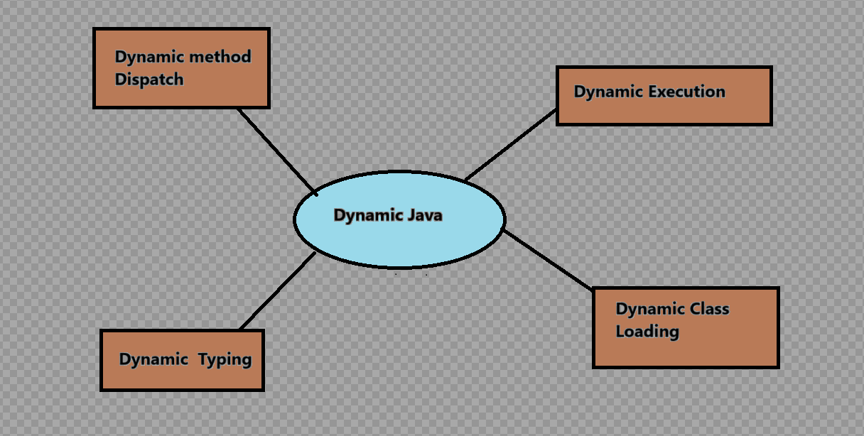

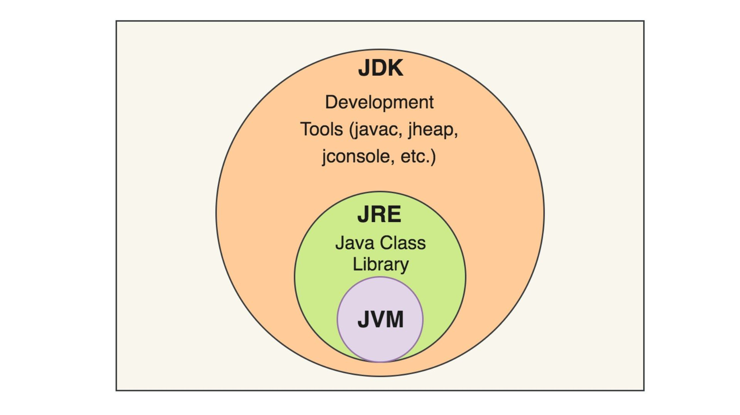
Que : What is JVM ??

JVM stand for java virtual machine

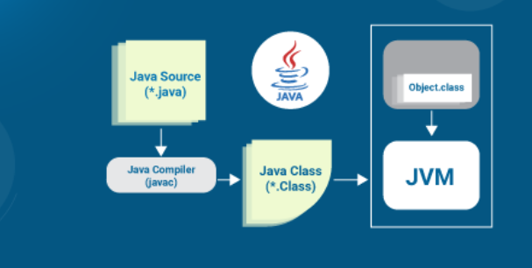
1.Java is abstract machine (Means its not machine just act like machine to execute the Java program
2.JVM is key component of java which provide the Java Runtime environment (JRE)
3. JVM Perform certain operation
1.Its load your class file or code
2.Its verify your code
3.Its execute your code
4.Its provide run time environment for your code

4.Also some the defination are done fromm jvm
Carbage collector handling
Memory are management
Register set
Error Reporting
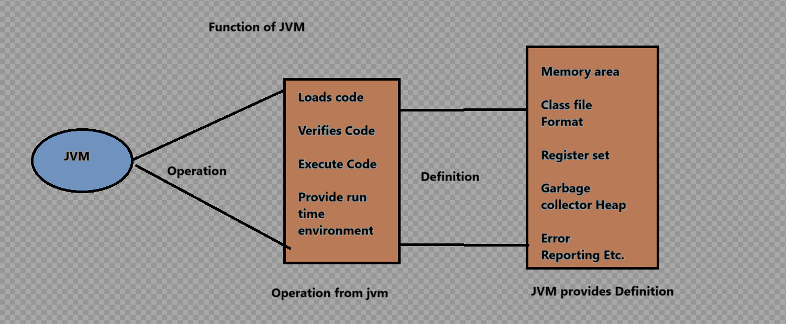
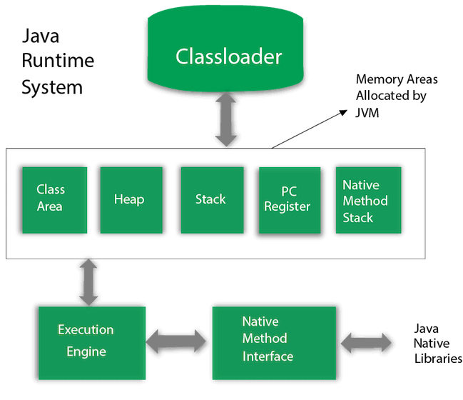

Next understanding after some content cover
JVM ARCHITECTURE

Que :- What are the types of JAVA Variables ?

What is variable ?

Java variable is container which is used to store the data and manipulate it.
Reserve spot as memory allocation which is used to hold the data
Some says Variable is just a box which holds the value

Que :- What are the types of variables?
There are mainly three types of variable
1.Local variable variable
2.Instance variable
3.static variable

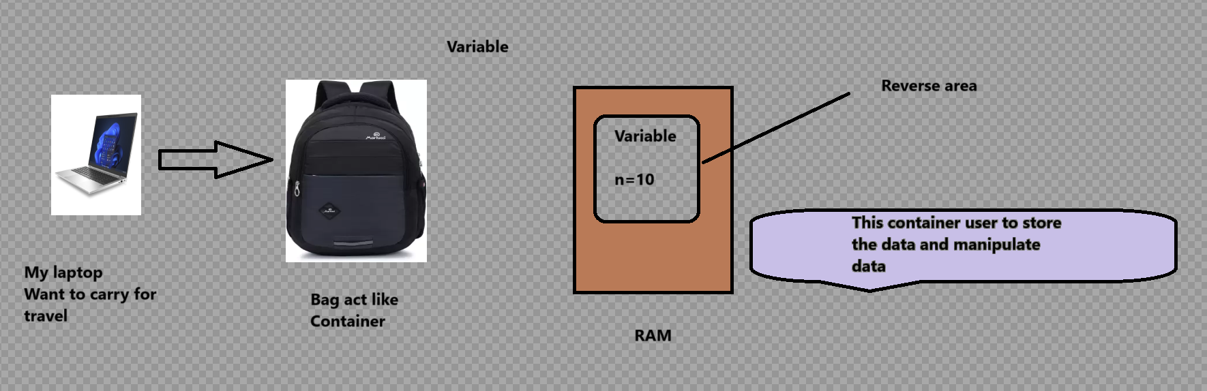

Que : Why we need variable in any programming language ?
Variable is very important in programming language which hold any datatype of value or data during running of program and in order to perform the operation
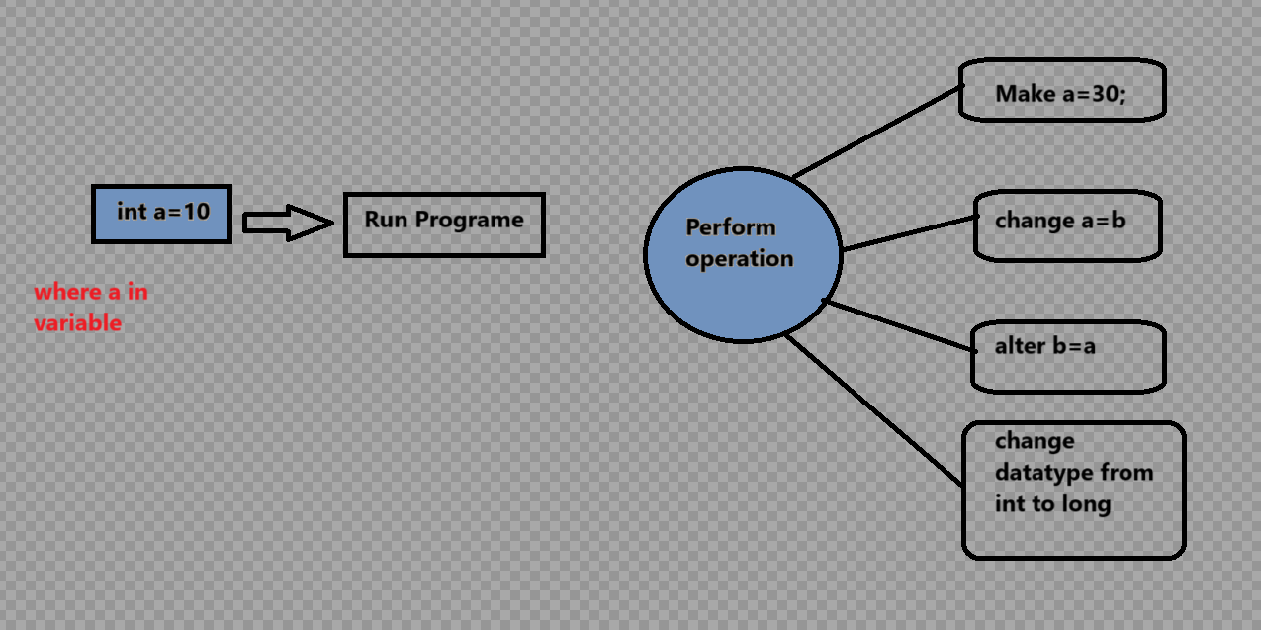

Que : If am not using Variable then what will be cause it?
Variable provide the way to store and manipulate the data if no variable there is no mechanism for manipulation and storage 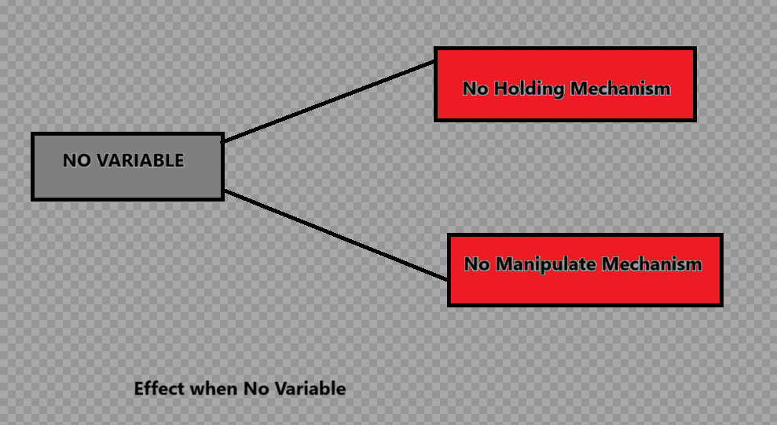

2.Variable also used to improve the readability of code and understanding different programming names convention

3. We can reuse the value by using variable 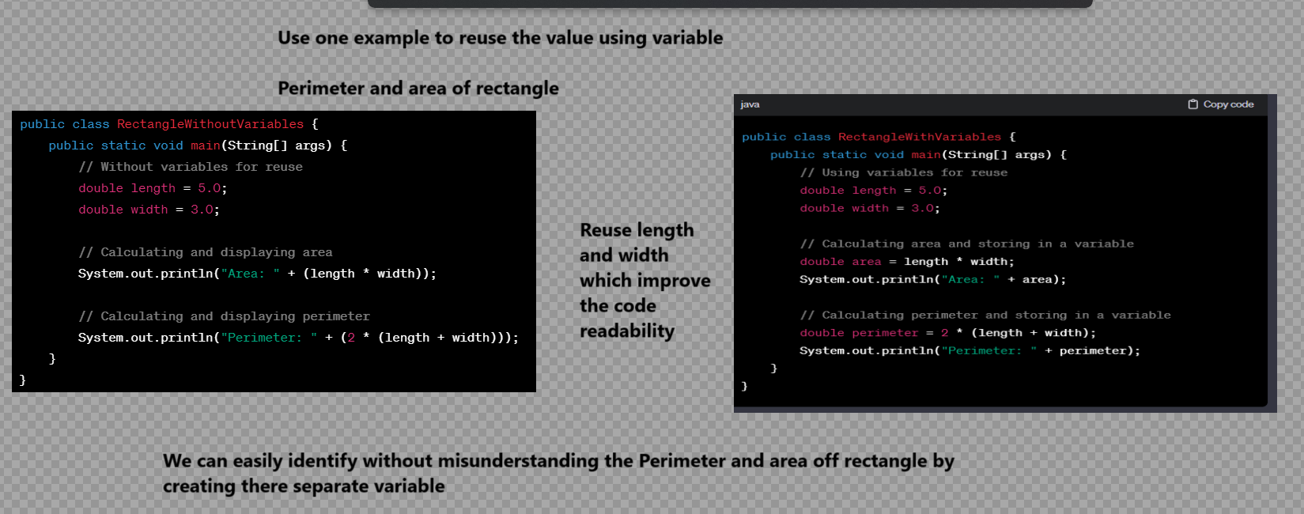
4.Debugging concept we can easily find out by using variable

5.Memmory management of java feature we can achieve
6.By using Variable we can make our more portable
7.Variable enables the program to make dynamic Program

LOCAL VARIABLE

